Newsroom portfolio website assignment :

Header—

1.Use the header component and create news(5), about me, contact me and homepage these pages should come in header with proper styling

Footer sections-

about me

contact me

latest 5 news-list with hyperlink should be open in new tab

social media section-

Page 1:

Page 2:

Page 4:

Page 5:

Contact Page:

About Page:

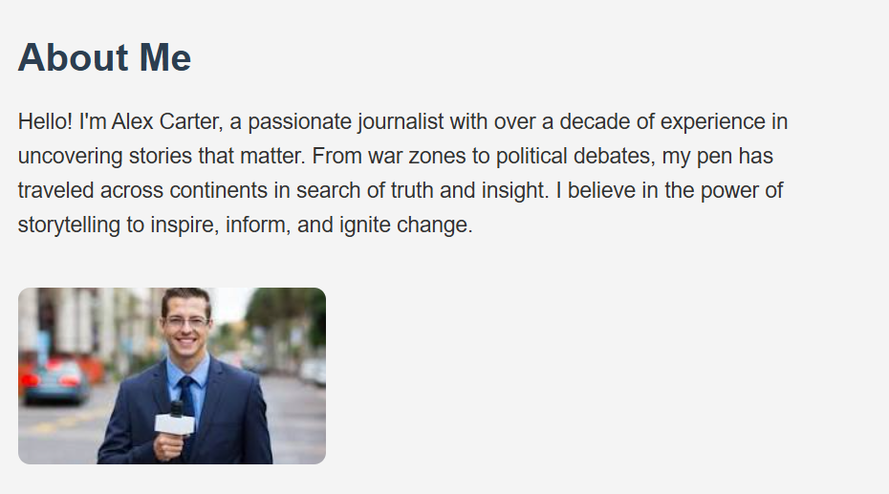

Social Media Page:

